STM32F407 + SEN0528 (ATH20) -> RTOS I2C Driver

- Introduction
  - Statement - Develop a POC to write a driver code in RTOS to display Temperature and Humidity over console.
  - Connect ATH20 Sensor to STM32F407 Board and read temperature and humidity data.
  - Display the data on console

- Devices
  - Reference Board: STM32
  - DEV Kit: STM32F407-DISC2
  - I2C Sensor: DFROBOT - SEN0528 (Based on ATH20)
  - OS: RTOS

- Connection
Sr. No. | STM32 Pin | ATH20 Pins | I2C Details
1 | PB6 | C | Clock
2 | PB9 | D | Data
3 | Gnd | - | Supply Gnd
4 | 3V | + | Supply Vcc

- Code details
  - Called function snippet is shown below

void StartDefaultTask(void *argument)
{
for(;;)
{
HAL_Delay(40); //40 ms delay at boot
uint8_t buffer[7] = {0}, status = 0xFF;
I2C_ReadData(SLAVE_ADDRESS, 1, buffer, &status); //Check Calibration bit of Status
if (status == 0)
printf("Read OK: Calibration State %02X n", buffer[0]);
else
{
buffer[0] = 0xBE;
buffer[1] = 0x08;
buffer[1] = 0x00;
I2C_WriteData(SLAVE_ADDRESS, 3, buffer, &status); //Initialize Cal //Send 0xBE command
HAL_Delay(10);
}
while(1)
{
buffer[0] = 0xAC;
buffer[1] = 0x33;
buffer[1] = 0x00;
I2C_WriteData(SLAVE_ADDRESS, 3, buffer, &status); //Start the measurement command
HAL_Delay(100); //80ms Delay
if (status == 0)
printf("Write OK\n");

memset(&buffer, 0x00, sizeof(buffer));
I2C_ReadData(SLAVE_ADDRESS, 7, buffer, &status);
if (status == 0)
printf("Read OK: %02X %02X %02X %02X %02X %02X %02X\n", buffer[0], buffer[1], buffer[2], buffer[3], buffer[4], buffer[5], buffer[6]);

uint32_t RawTemp, RawHum;
RawHum = ((buffer[1] << 12) | (buffer[2] << 4) | ((buffer[3] & 0xF0) >> 4));
RawTemp = ((buffer[3] & 0x0F) << 16) | (buffer[4] << 8) | (buffer[5]);

printf(" HUm %f, Temp %f \r\n", Convert_Humidity(RawHum), Convert_Temperature(RawTemp));
HAL_Delay(2000);
}
}
}

- Reference Driver files
  - I2C_Driver.c
  - I2C_Driver.h

- Status
  - Successfull read data from I2C sensor and display it on console.

- I2C Write Data Waveform
  - Configure I2C in Write mode by sending below command
    - (0x38 << 1)
  - Write Measurement Command as given below
    - 0xAC, 0x33, 0x00
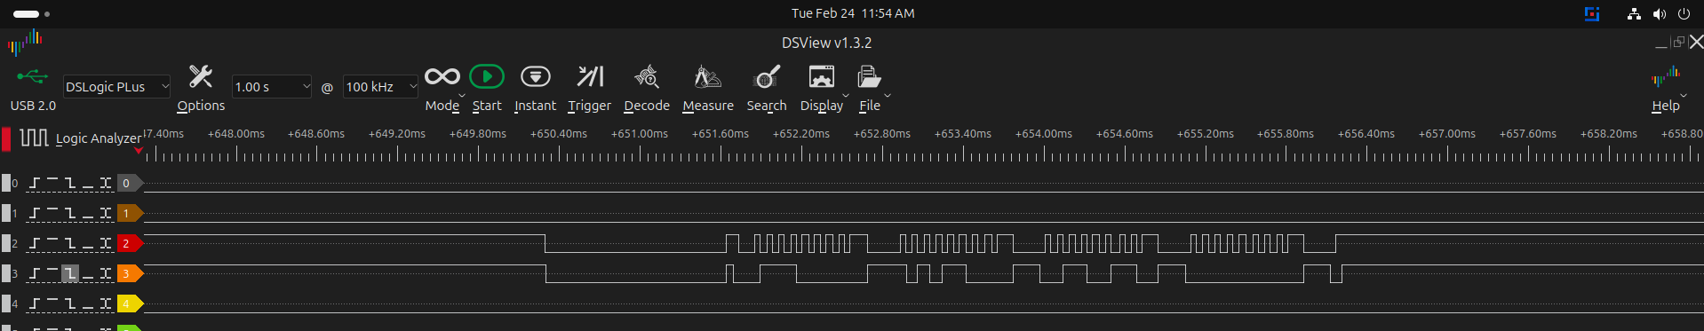

- I2C Read Data Waveform
  - Configure I2C in Write mode by sending below command
    - (0x38 << 1) | 1
  - Read 6 bytes to get Temperature and Humidity data
  - Convert the bytes into data
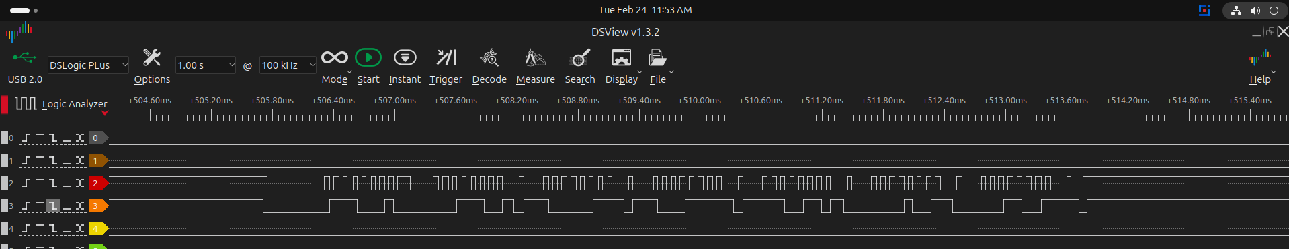

- Reference Links
  - STM32F407 Reference Manual
  - STM32F407 Data Sheet
  - ATH20 Data Sheet

